** College of Information Technology**

First Semester, A.Y. 2024-2025

**Midterm - Laboratory 2**

### Part A: Database and Table Creation

1. Create a new database named global_books_db
2. Create a comprehensive books table with the following structure:

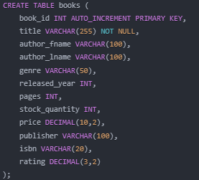

### Part C: Aggregate Function Queries

Complete the following analytical queries:

1. Basic Counting Queries

-- Total number of books

-- Number of unique authors

-- Number of books per genre

1. Grouping and Summarization

-- Average book price by genre

-- Total stock quantity per publisher

-- Number of books published per year

1. Advanced Analytical Queries

-- Top 5 authors by total book pages

-- Average rating for books published after 2000

-- Publishers with highest average book prices

1. Complex Aggregation Query

-- Create a comprehensive book performance report showing:

-- Genre, Total Books, Average Price, Total Stock, Average Rating

### Submission

### SQL Script File

* + Complete database creation script
  + All data insertion statements
  + All requested queries
  + Comments explaining each query's purpose